Course Project – Cesar Peña C.Jazinski

HTML/HTML5, CSS/CSS3 and JavaScript

**Designing Phase:**

**Mighty Nexus** - Video Game Tips Website

Website Hierarchy

Additional Pages – Featured Pages will all connect back to the other pages

**Main Page** – Design Idea

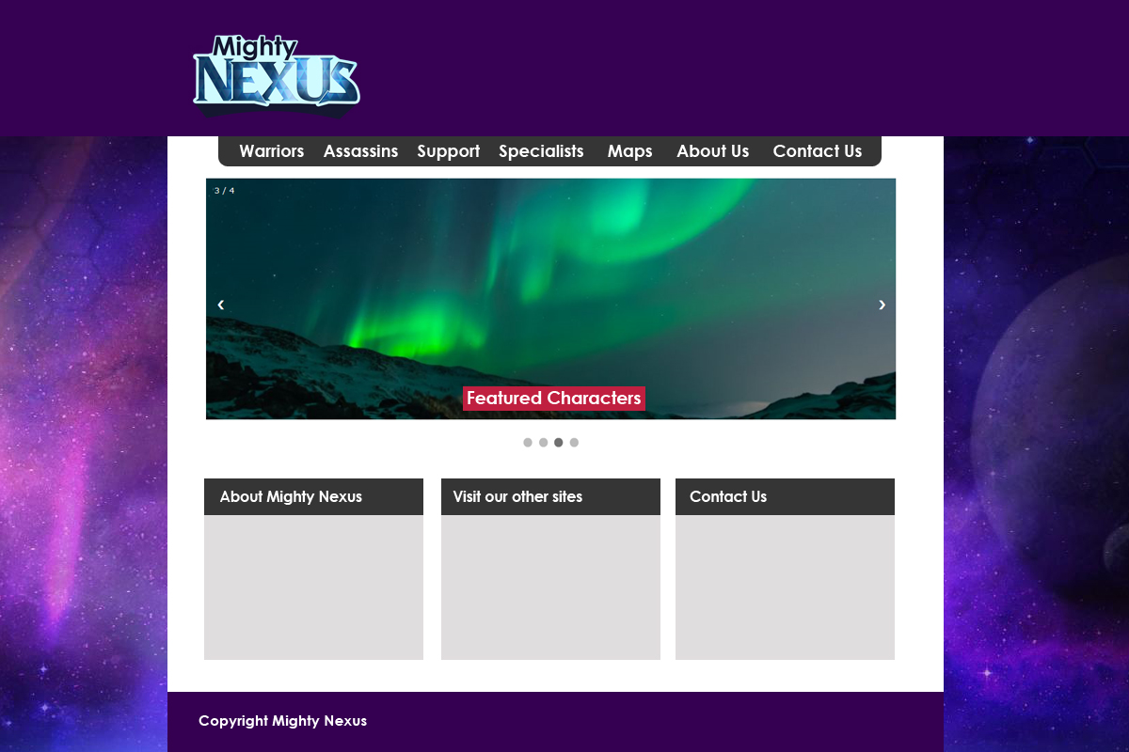

**Hex Values**

Purple: 360052

Dark Gray: 353535

Light Gray: e0ddde

Fuchsia: #e6005c

Dark Blue: #0e355a

**Character Pages**

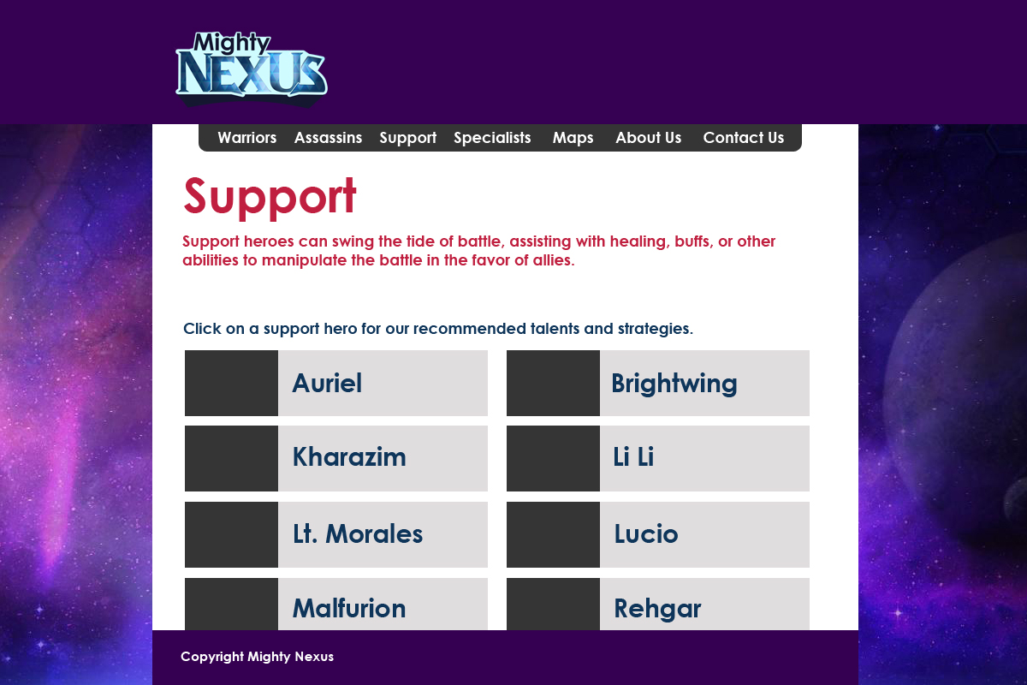

**Contact Us**

